Shayna Solomon

Module 5.2

**Function 1:** Concat

**Explanation:** An example of the Concat function would be if we have a table named Addresses with columns: Number, Street, City, and Zip. We can create a full address by combining these columns.

**Alias:** Full Address

**Statement**

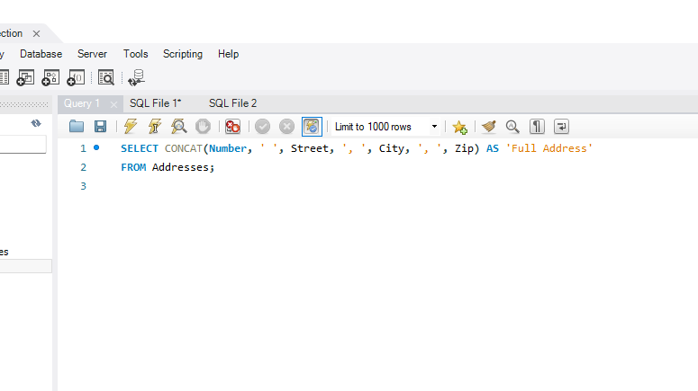

**Function 2:** Sum

**Explanation:**  An example the sum function would be if we calculate the total quantity of items ordered in a sales database.

**Alias:** Total Quantity

**Statement:**

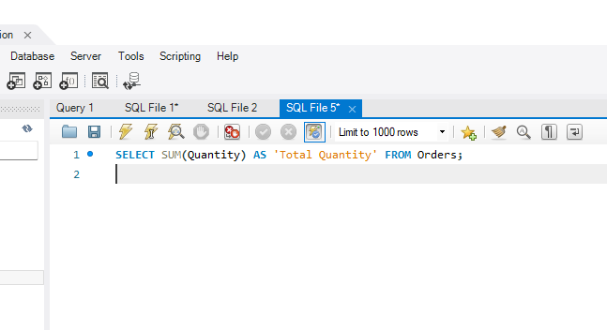

**Function 3:** Insert

**Explanation:** An example of the insert function would be if we have a table named Products with columns: ProductID, ProductName, and Price. We can insert a new product into the table.

**Alias:** New Product

**Statement:** 